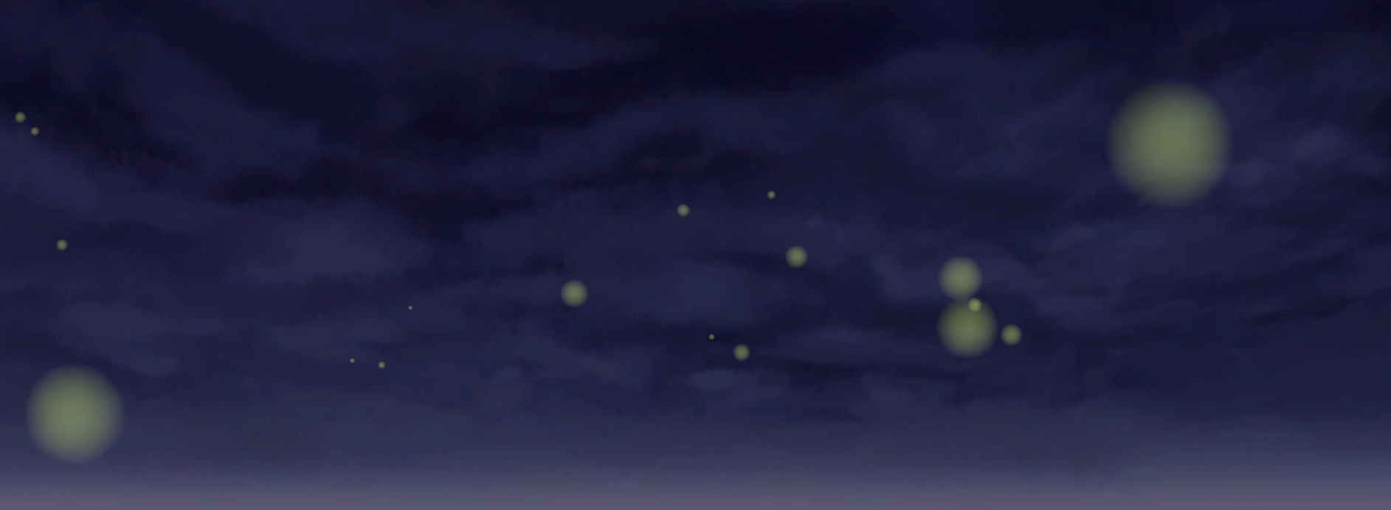

**FIREFLIES EXPERIENCE**

Aleksandra Musiał

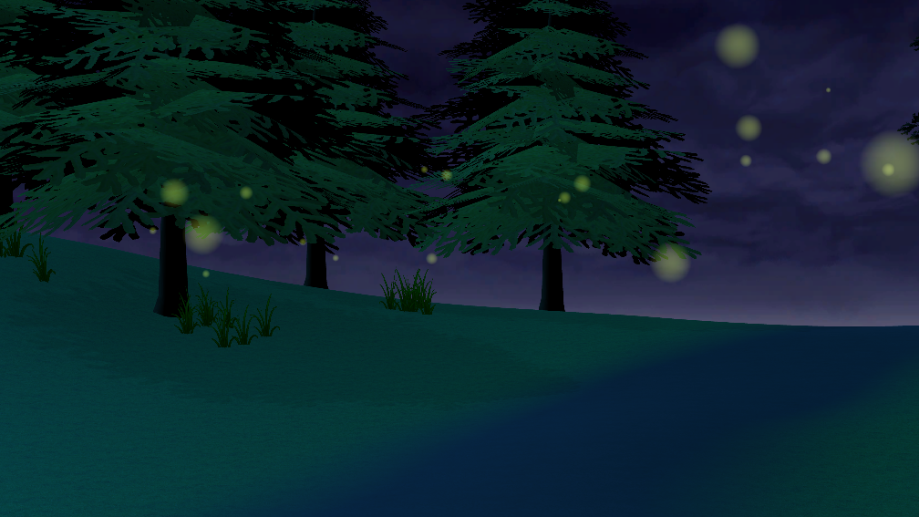

Nowadays, people can travel all over the World, and the only well-known limitation is money. However, not all the places can be visited by tourists, because of difficult or restricted access. Many wonderful miracles of nature cannot be seen, so they can be protected them. The solution for that could be the interaction experiences, similar to this one, which allows to see how the fireflies live. Moreover, this project allows to try alternative Natural User Interface (NUI), which tracks the hand movement - Leap Motion.

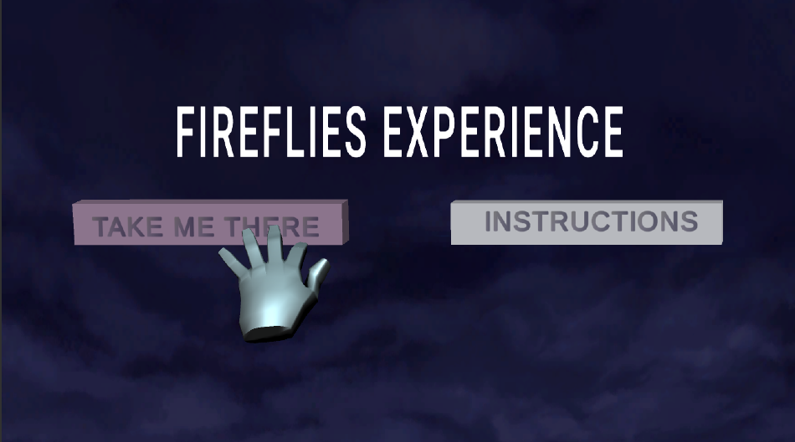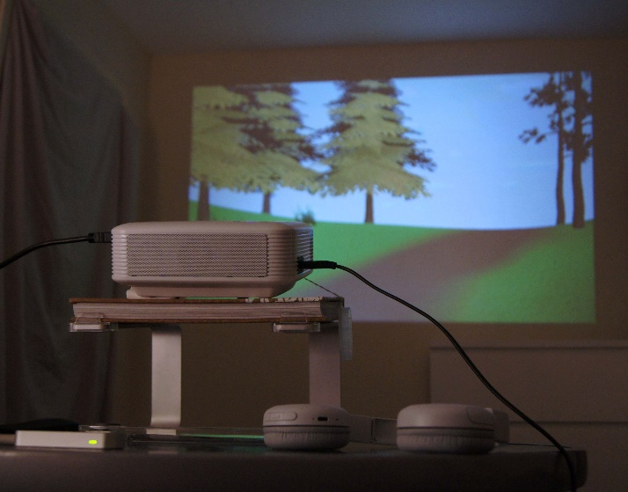It is an interactive art experience, which focuses on the technology, the nature and the human body movement. The users can take part in it from the first persons perspective. They are in the center of the forest, surrounded by the trees, bushes, lake and the outdoors sounds. While the night falls, the fireflies start to appear gradually. The movement around the scene can be performed by the hands gestures, which is possible because of the hand movement tracking device – Leap Motion.

**Software and technology used:**

* Unity version 2019.2.3f1
* Leap Motion Controller version 4.0
* Projector APEMAN LC350